**REAL TIME RIVER WATER QUALITY MONITORING AND CONTROL SYSTEM**

**Category: INTERNET OF THINGS**

A PROJECT REPORT

## Submitted by

**P. ADITYA SAGAR**

**G. ROHITH**

**M. SUNIL**

**L. DHINA**

***FROM***

**Dr. MAHALINGAM COLLEGE OF ENGINEERING AND TECHNOLOGY, POLLACHI**

***In fulfillment of project in IBM-NALAYATHIRAN 2022 Team Id: PNT2022TMID08711***

**PROJECT GUIDES**

### Industry Mentor: Bharadwaj

### Faculty Mentor: Mrs. Sherine Jenny

**INDEX**

1. **INTRODUCTION** 
   1. Project Overview
   2. Purpose
2. **LITERATURE SURVEY**
   1. Existing problem
   2. References
   3. Problem Statement Definition
3. **IDEATION & PROPOSED SOLUTION**
   1. Empathy Map Canvas
   2. Ideation & Brainstorming
   3. Proposed Solution
   4. Problem Solution fit
4. **REQUIREMENT ANALYSIS**
   1. Functional requirement
   2. Non-Functional requirements
5. **PROJECT DESIGN**
   1. Data Flow Diagrams
   2. Solution & Technical Architecture
   3. User Stories
6. **PROJECT PLANNING & SCHEDULING**
   1. Sprint Planning & Estimation
   2. Sprint Delivery Schedule
   3. Reports from JIRA
7. **CODING & SOLUTIONING (Explain the features added in the project along with code)**
   1. Feature 1
   2. Feature 2
   3. Database Schema (if Applicable)
8. **TESTING** 
   1. Test Cases
   2. User Acceptance Testing
9. **RESULTS**
   1. Performance Metrics
10. **ADVANTAGES & DISADVANTAGES**
11. **CONCLUSION**
12. **FUTURE SCOPE**
13. **APPENDIX**

Source Code

GitHub & Project Demo Link

# 1. INTRODUCTION

* 1. **Project Overview**:

### River Water quality monitoring System

River water which is used as drinking water is a very precious commodity for all human beings. The system consists of several sensors which are used for measuring physical and chemical parameters of water. The parameters such as temperature, pH, and dissolved oxygen of the water can be measured. Using this system, a person can detect pollutants from a water body from anywhere in the world. Current water quality monitoring system is a manual system with a monotonous process and is very time-consuming This paper proposes a sensor- based water quality monitoring system. The main components of Wireless Sensor Network (WSN) include a micro-controller for processing the system, communication system for inter and intra node communication and several sensors Real-time data access can be done by using remote monitoring and Internet of Things (IoT) technology Data collected at the IBM cloud Server and verify them to trigger the actions to be performed.

* 1. **Purpose:**

Water quality refers to chemical, physical biological and radio logical characteristics of water. It is a measure of the condition of water relative to the necessities of one or more bio-tic species and or to any human need or purposes. Water quality monitoring is defined as a sampling and analysis of the water in lake, stream, ocean and river and conditions of the water body. Smart water quality monitoring is a process of real-time monitoring and the analysis of water to identify changes in parameters based on the physical, chemical and biological characteristics. Monitoring water quality is clearly important: in our seas, our

rivers, on the surface and in our ports, for both companies and the public. It enables us to assess how they are changing, analyze trends and to inform plans and strategies that improve water quality and ensures that water meets its designated use. There are several indicators determining water quality. These include dissolved oxygen, turbidity, bio indicators, nitrates, pH scale and water temperature. Monitoring water quality helps to identify specific pollutants, a certain chemical, and the source of the pollution. There are many sources of water pollution: wastewater from sewage seeping into the water supply; agricultural practices (e.g., the use of pesticides and fertilizer); oil pollution, river and marine dumping, port, shipping and industrial activity. Monitoring water quality and a water quality assessment regularly provides a source of data identify immediate issues – and their source.

* + - Identifying trends, short and long-term, in water quality.
    - Data collected over a period of time will show trends, for example identifying increasing concentrations of nitrogen pollution in a river or an inland waterway. The total data will then help to identify key water quality parameters.
    - Environmental planning methods: water pollution prevention and management.
    - Collecting, interpreting, and using data is essential for the development of a sound and effective water quality strategy. The absence of real-time data will however hamper the development of strategies and limit the impact on pollution control. Using digital systems and programs for data collection and management is a solution to this challenge.
    - Monitoring water quality is a global issue and concern: on land and at sea. Within the European Union, the European Green Deal sets out goals for restoring biological biodiversity and reducing water pollution, as well as publishing various directives to ensure standards of water quality. Individual nation states, for example France, have also clear regulatory frameworks requiring the effective monitoring of water quality. In the United States, the Environmental Protection Agency (EPA) enforces regulations to address water pollution in each state. Across the world, countries increasingly understand the importance of effective water quality monitoring parameters and methods.

# 2. LITERATURE SURVEY

* 1. **Existing Problem:**

Due to population growth, urbanization, and climatic change ,competition for water resources is expected to increase, with a particular impact on agriculture, river water. Water will be suitableness to potable water monitoring compound spillage identification done rivers, remote estimation for swimming pools. It holds self-sufficient hubs that unite with the cloud to ongoing water control. The river water needed to be treated before it is used in agriculture fields, hence the parameters affecting the quality of river-water need to be analyzed and to be used for water treatment purpose.

* 1. **References:**

Dr.Geetha [1] :IoT based real time water quality monitoring system using smart sensor. WQM is a cost effective and efficient system designed to monitor drinking water quality with the help of IOT(2020).

Natasha Markovic [2]: this research paper focuses on Sensor Web for River Water Pollution Monitoring and Alert System Sensor Web has provided infrastructure for collecting and processing data from distributed and heterogeneous sensors. This set of technologies has found various implementations, especially in the area of environmental monitoring. The Sensor Web architecture for crisis management, described in this paper, provides active monitoring of measuring parameters and timely responses in cases of environmental disasters. The River Water Management and Alert System built on this architecture enable access, control, and management of river water pollution.

K. A. UnnikrishnaMenon [3]: This research paper focuses on Wireless Sensor Network for River Water Quality Monitoring in India This paper introduces a river water quality monitoring system based on wireless sensor network which helps in continuous and remote monitoring of the water quality data in India. The wireless sensor node in the system is designed for monitoring the pH of water, which is one of the main parameters that affect the quality of water. Wireless sensor Network which aids in River Water Quality Monitoring. This paper also proposes a novel technique for the design of a water quality sensor node which can be used for monitoring the pH of water.

Aswinkumar [4]: This research paper focuses on Detection on water pollution and water management using smart sensors iot. To ensure the safe supply of drinking water the quality should be monitored in real time for that purpose new approach IOT (Internet of Things) based water quality monitoring has been proposed. This system consists some sensors. Which measure the water quality parameter such as pH, turbidity, conductivity, dissolved oxygen, temperature. The measured values from the sensors are processed by microcontroller and these processed values are transmitted remotely to the core controller that is raspberry pi using Zigbee protocol. Based on a study of existing water quality monitoring system and scenario of water we can say that proposed system is more suitable to monitor water quality parameters in real time.

Leonid Stoimenovet [5]: this research paper focuses on Sensor Web for River Water Pollution Monitoring and Alert System Sensor Web has provided infrastructure for collecting and processing data from distributed and heterogeneous sensors. This set of technologies has found various implementations, especially in the area of environmental monitoring. The Sensor Web architecture for crisis management, described in this paper, provides active monitoring of measuring parameters and timely responses in cases of environmental disasters. The River Water Management and Alert System built on this architecture enable access, control, and management of river water pollution.

Maneesha V. Ramehet [6]: This research paper focuses on Wireless Sensor Network for River Water Quality Monitoring in India This paper introduces a river water quality monitoring system based on wireless sensor network which helps in continuous and remote monitoring of the water quality data in India. The wireless sensor node in the system is designed for monitoring the pH of water, which is one of the main parameters that affect the quality of water. Wireless sensor Network which aids in River Water Quality Monitoring. This paper also proposes a novel technique for the design of a water quality sensor node which can be used for monitoring the pH of water.

* 1. **Problem Statement:**

Due to the fast-growing urbanization supply of safe drinking water is a challenge for every city authority. Water can be polluted any time.

• So, the water we reserved in the water tank at our roof top or basement in our society or apartment may not be safe. Still in India most of the people use simple water purifier that is not enough to get surety of pure water. The traditional water quality monitoring system has certain drawbacks.

• Sometimes the water has dangerous particles or chemical mixed and general-purpose water purifier cannot purify that. It relies on collecting of water samples, testing and analyses in laboratories and it’s impossible to check the quality of water manually in every time.

• It results in more cost, more man power and more time. Also, it lacks capability for real-time data collections. So, an automatic real-time monitoring system is required to monitor the health of the water reserved in our water tank of the society or apartment.

So it can warn us automatically if there is any problem with the reserved water. And we can check the quality of the water anytime and from anywhere. By keeping this mind, we designed this system especially for residential areas.

**3. IDEATION & PROPOSED SOLUTION**

* 1. **Empathy Map Canvas:**

An empathy map is a simple, easy-to-digest visual that captures knowledge about a user’s behaviors and attitudes. It is a useful tool to helps teams better understand their users. Creating an effective solution requires understanding the true problem and the person who is experiencing it. The exercise of creating the map helps participants consider things from the user’s perspective along with his or her goals and challenges.

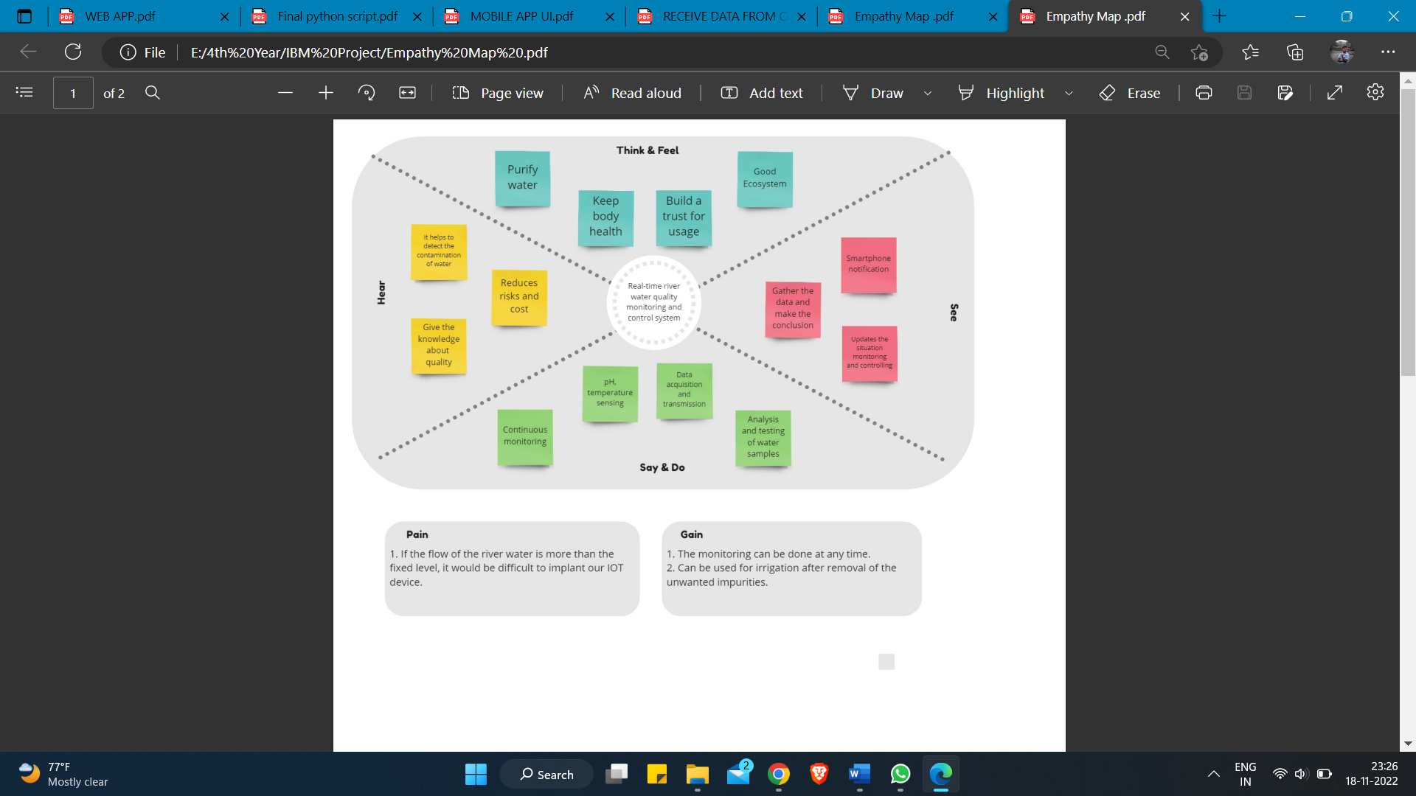

* 1. **Ideation & Brainstorming:**

Brainstorming provides a free and open environment that encourages everyone within a team to participate in the creative thinking process that leads to problem solving. Prioritizing volume over value, out-of-the-box ideas are welcome and built upon, and all participants are encouraged to collaborate, helping each other develop a rich amount of creative solutions.

Use this template in your own brainstorming sessions so your team can unleash their imagination and start shaping concepts even if you're not sitting in the same room.

Reference:<https://app.mural.co/t/realtimeriverwaterqualitymon5861/m/realtimeriverwaterqualitymon5861/1665483325999/6aab5ed19da9d6a9471d80b6b568330d2a499d71>

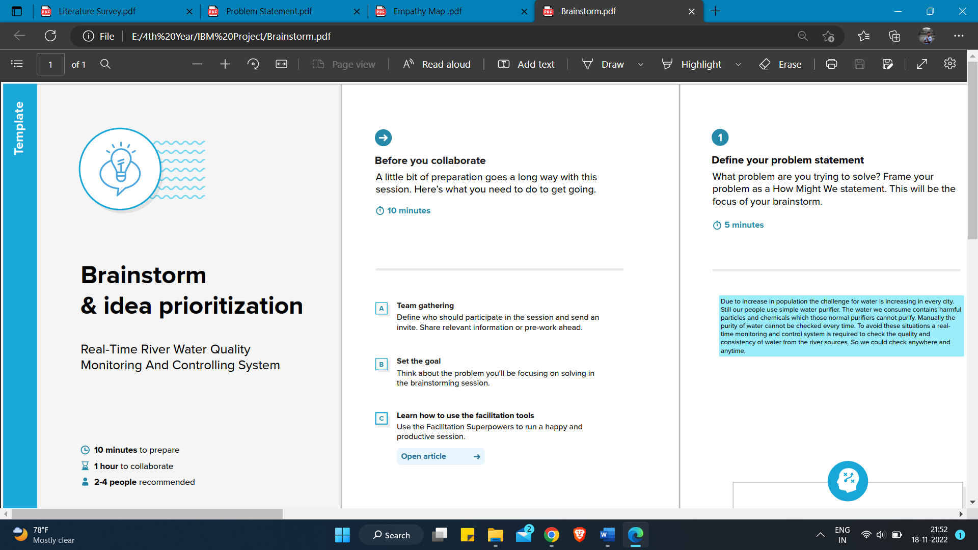

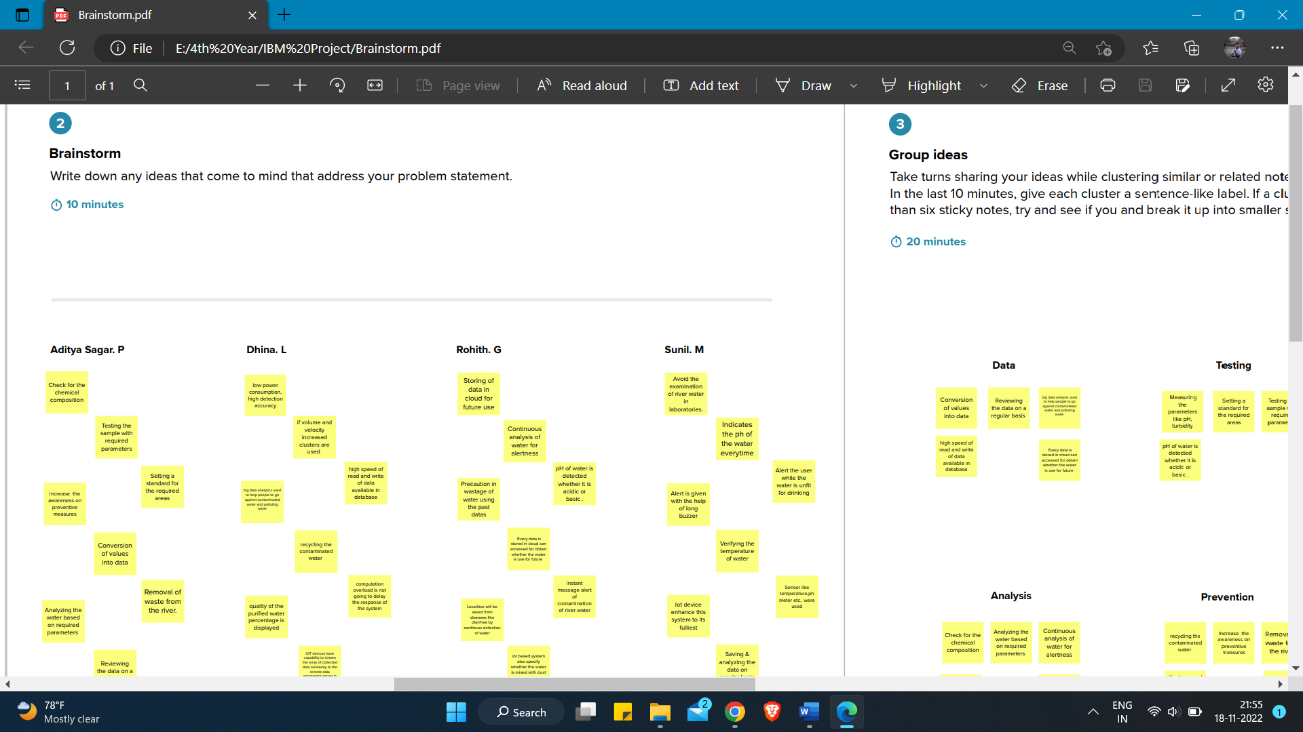

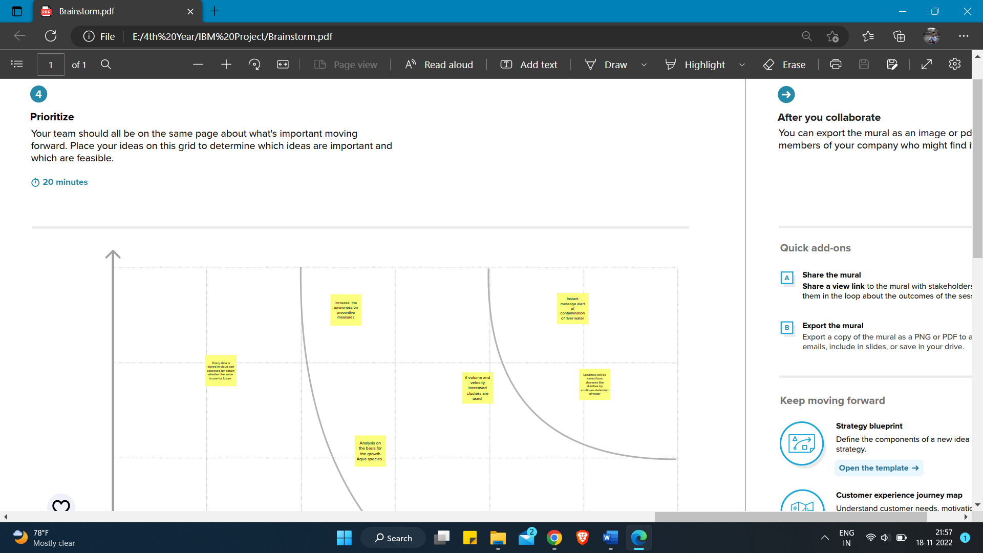

* 1. **Proposed Solution:**

|  |  |  |
| --- | --- | --- |
| **S.No.** | **Parameter** | **Description** |
| 1. | Problem Statement (Problem to be solved) | Due to population growth, urbanization, and climatic change, competition for water resources is expected to increase, with a particular impact on agriculture, river water. |
| 2. | Idea / Solution description | To monitor the water supply we implement IoT (Internet of Things) setup, for river water quality monitoring systems periodically checks, dust particles, temperature and PH level by sensors and notifies for public when the water quality varies. |
| 3. | Novelty / Uniqueness | We use water detection sensor has unique advantage. It consumes less time to monitor than a manual method for checking polluted levels, and notifies immediately to reduce  affected rate of pollution in water. |
| 4. | Social Impact / Customer Satisfaction | People who are living in rural areas near to the river will be very satisfied with our idea. It will be useful to monitor water pollution in specific area. So this system prevent people from water pollution. It will be used for farming purpose to check quality water, temperature and PH level. Our Impact of this project is also create a social satisfaction for farmers too. |

|  |  |  |
| --- | --- | --- |
| 5. | Business Model (Revenue Model) | It costs low compared to another model. Our real time quality monitoring model has sensors easily helps to monitor and predict the affected water scale easily in farming, drinking water, aquaculture, and other industries. It notifies by sending directly to the corporation and they can further notify the people to aware immediately. Quick actions can be taken. With the help of efficient use of mobile network, IoT and continuous monitoring it will be revolutionized model. |
| 6. | Scalability of the Solution | Checking the river water quality for providing clean drinking water for the people, farming, promoting aquaculture, and other industries. It is the best replacement for checking water quality in laboratories and it is user-friendly. If we add more advanced sensors in future it can be used to monitor multiple levels in water. It will show continuous real time values in maintaining the quality of water. |

### PROBLEM SOLUTION:

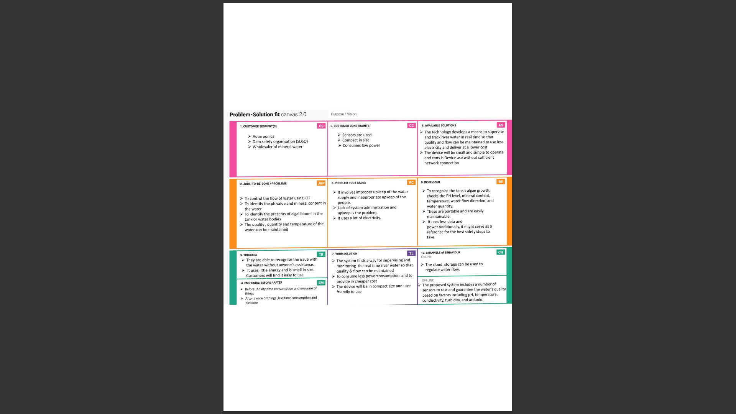

**4. REQUIREMENT ANALYSIS**

* 1. **Functional Requirements:**

Following are the functional requirements of the proposed solution.

|  |  |  |
| --- | --- | --- |
| **FR No.** | **Functional Requirement**  **(Epic)** | **Sub Requirement (Story / Sub-Task)** |
| FR-1 | User Registration | Registration through Form Registration through Gmail  Registration through Linkedin |
| FR-2 | User Confirmation | Confirmation via Email  Confirmation via OTP |
| FR-3 | Ultrasonic generator | Periodically the waves are generated to destroy algae in the range of  25%,50%,100% |
| FR-4 | Ph level detection | To observe the water quality, Ph sensor is used and the  signals are conveyed to the Arduino. |
| FR-5 | Turbidity detection | Turbidity sensor measures the purity of element or marshy utter in the water and the signals are delivered  to Arduino |

* 1. ***Non-functional Requirements:***

Following are the non-functional requirements of the proposed solution.

|  |  |  |
| --- | --- | --- |
| **FR No.** | **Non-Functional Requirement** | **Description** |
| NFR-1 | **Usability** | Monitors the ﬂow and quality of  ground water, and investigates surface- and ground-water  interactions. |
| NFR-2 | **Security** | The data and information are secured  in the application by using the application ﬁrewall. |
| NFR-3 | **Reliability** | The Real time sensor output values  with future predicted data storage with output eﬃciency of 98%. It also  gives certainty for aquaculture safety. |
| NFR-4 | **Performance** | The performance of system has higher  eﬃciency and environmentally friendly. |
| NFR-5 | **Availability** | It is available in the form of mobile UI  24 x 7 monitoring system. |
| NFR-6 | **Scalability** | The system has high scalability. Able  to be changed in size or scale to give the best output. |
| NFR-7 | **Stability** | The ability of the system to bring itself  back to its stable configuration. The stability is high. |
| NFR-8 | **Eﬃciency** | The monitoring system is highly  eﬃcient, high mobility with consumption of power. |

**5 PROJECT DESIGN**

* 1. **Data Flow Diagrams:**

A Data Flow Diagram (DFD) is a traditional visual representation of the information flows within a system. A neat and clear DFD can depict the right amount of the system requirement graphically. It shows how data enters and leaves the system, what changes the information, and where data is stored.

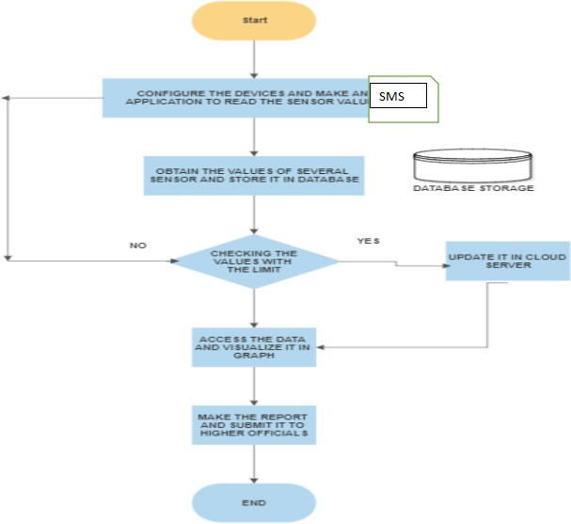

# Solution And Technical Architecture

**Summary**

This code pattern explains how to build an IOT based river water monitoring and controlling system with some predefined values.

**Flow**

* + - Feed the data received from the Sensor unit which are placed in the river sides.
    - The collected data will be displayed in the Web page to the user.
    - Then the collected data is sent to the data base, where the collected data and the predefined data are checked and monitored.
    - If any data exceed the predefined data, then the control signal will send to the Admin.
    - The collected data will be stored in the IBM cloud storage. Later the data will be controlled by the admin via Web UI

**Components & Technologies:**

|  |  |  |  |
| --- | --- | --- | --- |
| S.No | Component | Description | Technology |
| 1. | Sensor Data | The data is collected form the various sensor placed  in the river sides. | ESP32Wifi module Raspberry Pie. |
| 2. | Database for Storage | The data/info need to be stored for accessing it in  future | MySQL-Oracle |
| 3. | File Storage | File storage requirements | IBM Block Storage or Other Storage Service or Local Filesystem |
| 4. | Cloud Database | Database Service on  Cloud | IBM cloud |
| 5. | Data Storage | File storage requirements | IBM Block Storage |

**Application Characteristics:**

|  |  |  |  |
| --- | --- | --- | --- |
| S.No | Characteristics | Description | Technology |
| 1. | PH level Monitoring | The PH level of river water can be monitoredvia placing sensors in  rivers. | PH-sensor |
| 2. | Air Quality Monitoring | The clarity and purity ofriver water can be monitored | Surface Mount Sensor |
| 3. | Temperature Monitoring | The temperature of river water can be monitored | Temperature sensor |
| 4. | Water Treatment | can be used as both a safety device in the water purification process as carbon dioxide, methane, and carbon monoxide are some of the key gases produced during the  treatment process | NDIR gas sensors |
| 4. | Soil Condition Monitoring | Soil condition monitoring sensors allow farmers to collect data about rainfall, temperature, and other metrics over time to track trends and predict irrigation needs. | Acoustic sensor |

* 1. **User Stories**

Use the below template to list all the user stories for the product.

|  |  |  |  |  |  |  |
| --- | --- | --- | --- | --- | --- | --- |
| **Sprint** | **Functional**  **Requirement (Epic)** | **User story Number** | **User Story / Task** | **Story Points** | **Priority** | **Team Members** |
| Sprint-1 | Registration | USN-1 | As a user, I can register for the application by entering my email, password, and confirming My password. | 2 | High | ADITYA SAGAR. P  ROHITH. G  SUNIL. M  DHINA. L |
| Registration via Facebook | USN-3 | As a user, I can register for the application through Facebook | 2 | Low |
| Registration via Mail ID | USN-4 | As a user, I can register for the application through Gmail | 2 | Medium |
| Sprint-2 | Confirmation | USN-2 | As a user, I will receive confirmation email once I have registered for the application | 1 | High |
| Login | USN-5 | As a user, I can log into the application by entering email & password | 1 | High |
|  | IBM Cloud service Access | Get access to IBM cloud services. | 2 | High |
| Sprint-3 | Create the IBM Watson IoT and device Settings | USN-6 | To create the IBM Watson IoT Platform and integrate the microcontroller with it, to send the sensed data on  Cloud | 2 | High | ADITYA SAGAR. P  ROHITH. G  SUNIL. M |
| Create a node red service | USN-7 | To create a node red service to integrate the IBM Watson along with the Web UI | 2 | medium | ROHITH. M  SUNIL. G  DHINA. L |
| Create a Web UI | USN-8 | To create a Web UI, to access the data from the cloud and display all parameters. | 2 | Medium | ROHITH. G |
| To develop a Python code | USN-9 | Create a python code to sense the physical quantity and store data. | 2 | Medium | SUNIL. M |

|  |  |  |  |  |  |  |
| --- | --- | --- | --- | --- | --- | --- |
|  |  |  |  |  |  | ROHITH. G |
| Publish Data to cloud. | USN-10 | Publish Data that is sensed by the microcontroller to the Cloud | 3 | High | DHINA. L |
| Sprint-4 | Fast-SMS Service | USN-11 | Use Fast SMS to send alert messages once the  parameters like pH, Turbidity and temperature goes beyond the threshold | 3 | High | ADITYA SAGAR. P  ROHITH. G  SUNIL. M |
|  | Testing | USN-12 | Testing of project and final deliverables | 3 | Medium |

# 6. PROJECT PLANNING AND SCHEDULING

### SPRINT PLANNING & SCHEDULING:

|  |  |  |
| --- | --- | --- |
| **TITLE** | **DESCRIPTION** | **DATE** |
| **Literature Survey &**  **Information Gathering** | Literature survey on  the selected project is done by gathering information about related details on technical papers and  web browsing. | 06 OCTOBER  2022 |
| **Empathy Map** | Prepared Empathy Map  Canvas to combine thoughts and pains, gains of the project with all team members. | 08 OCTOBER  2022 |
| **Ideation** | Brainstorming session is conducted with all team members to list out all the ideas and prioritize the top 3 ideas. | 09 OCTOBER  2022 |
| **Proposed Solution** | Prepared the proposed solution document, which includes the novelty, feasibility of idea, business model, social impact, scalability of solution, etc. | 28 OCTOBER  2022 |
| **Problem Solution Fit** | Prepared problem - solution ﬁt document. | 30 OCTOBER  2022 |

* 1. **SPRINT DELIVERY SCHEDULE**

**Product Backlog, Sprint Schedule, and Estimation**

|  |  |  |  |
| --- | --- | --- | --- |
| **SI.**  **NO** | **ACTIVITY TITLE** | **ACTIVITY DESCRIPTION** | **DURATION** |
| 1. | Understanding the project requirement | Assign the team members and create a repository in the GitHub. Assign the task to each member and teach how to use and open and class the GitHub and IBM career education | 1 WEEK |
| 2. | Starting of project | Advise students to attend classes of IBM portals, create and develop a rough diagram based on project description and gather  information on IOT and IBM projects and team leaders assign tasks to each member of the project | 1 WEEK |
| 3. | Attend class | Team members and team lead must watch and learn from classes provided by IBM and NALAYATHIRAN and must gain access of MIT license for their project. | 4 WEEKS |
| 4. | Budget and scope of project | Budget and analyze the use of IOT in the project and discuss with team for budget prediction to predict the favorability for the customer to buy. | 1 WEEK |

**Project Tracker, Velocity & Burndown Charts**

|  |  |  |  |  |  |  |
| --- | --- | --- | --- | --- | --- | --- |
| **Sprint** | **Total**  **Story Points** | **Duration** | **Sprint Start Date** | **Sprint End Date (Planned)** | **Story Points Completed (as on Planned End Date)** | **Sprint Release Date (Actual)** |
| Sprint-1 | 20 | 4 Days | 24 Oct 2022 | 27 Oct 2022 | 20 | 29 Oct 2022 |
| Sprint-2 | 20 | 5 Days | 28 Oct 2022 | 01 Nov 2022 | 20 | 04 Nov 2022 |
| Sprint-3 | 20 | 8 Days | 02 Nov 2022 | 09 Nov 2022 | 20 | 11 Nov 2022 |
| Sprint-4 | 20 | 9 Days | 10 Nov 2022 | 18 Nov 2022 | 20 | 19 Nov 2022 |

**Velocity:**

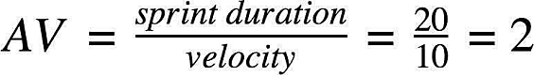

### Burndown Chart:

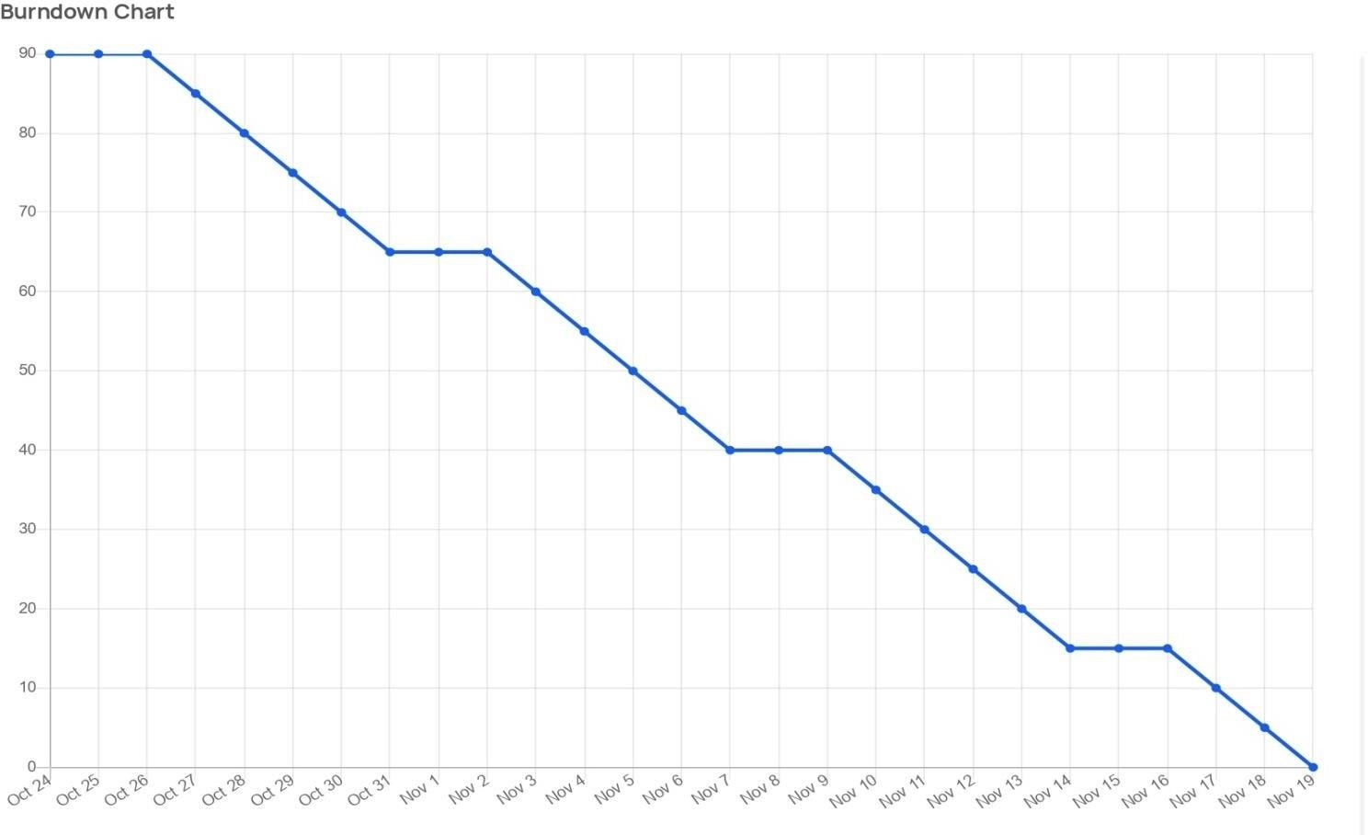

* 1. **REPORT FROM JIRA**

**TIMELINE CREATED USING JIRA SOFTWARE**

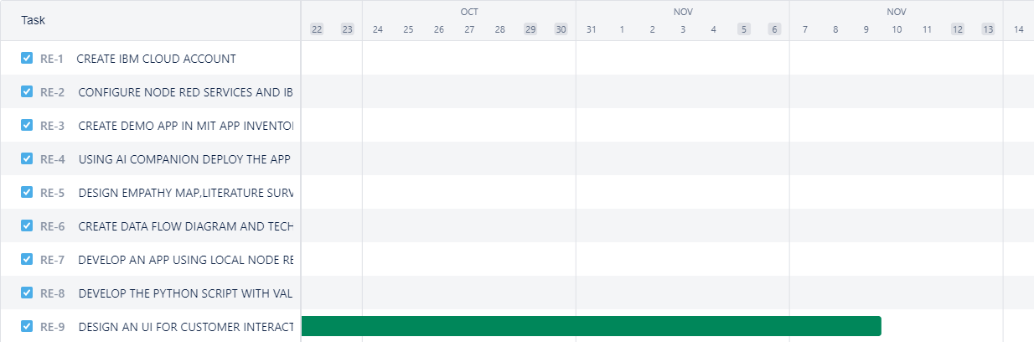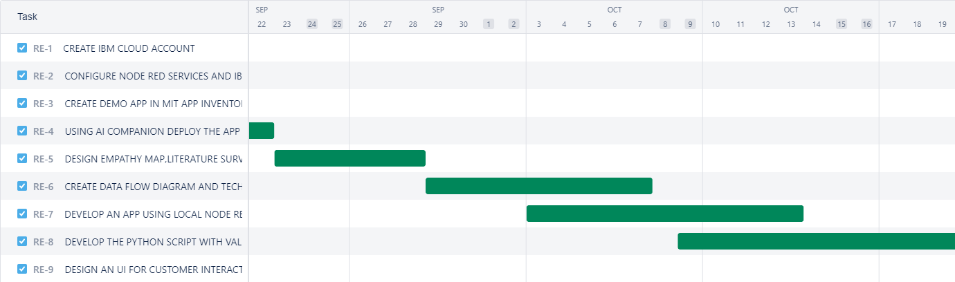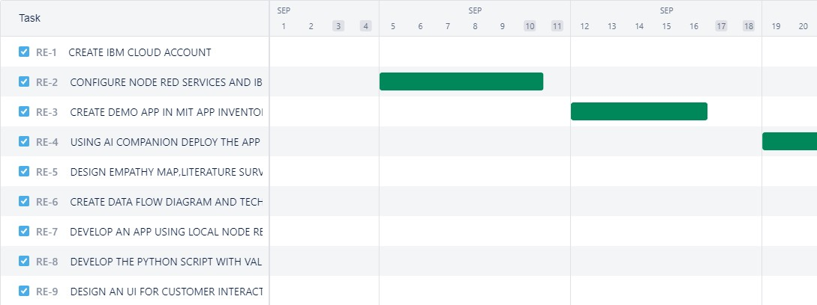

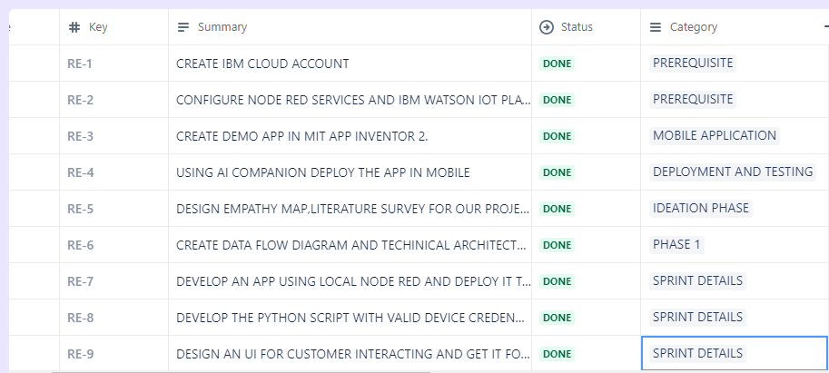 **LISTS IN JIRA:**

**ISSUES:**

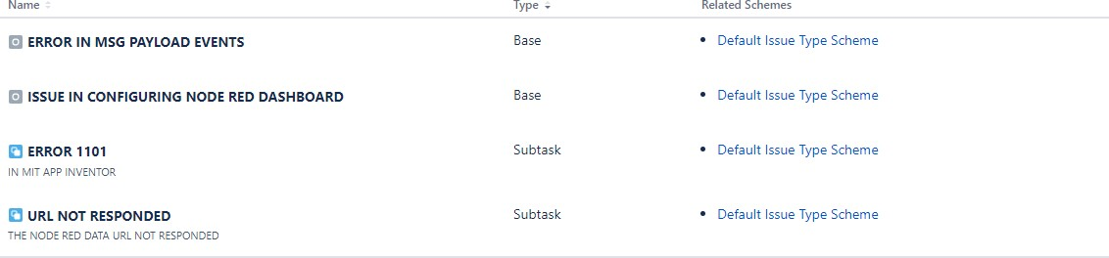

**7. CODING AND SOLUTIONING**

**7.1 NODE RED SERVICE ASSOCIATED WITH IBM CLOUD:**

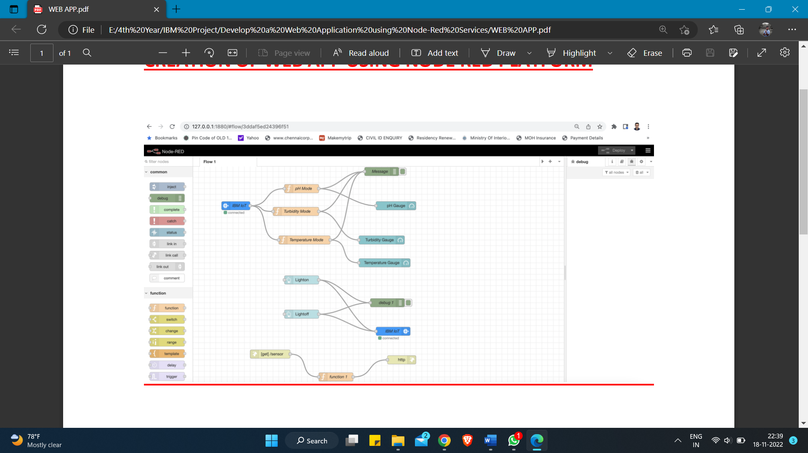

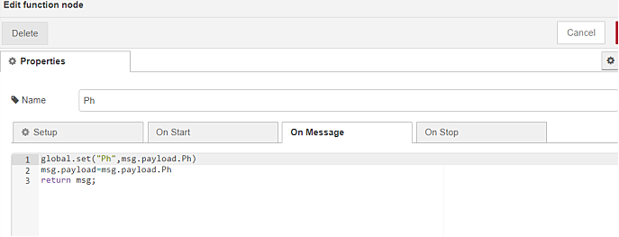

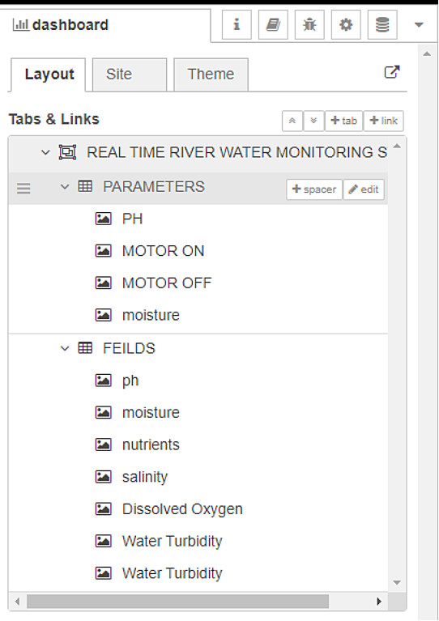**Node red Dashboard:**

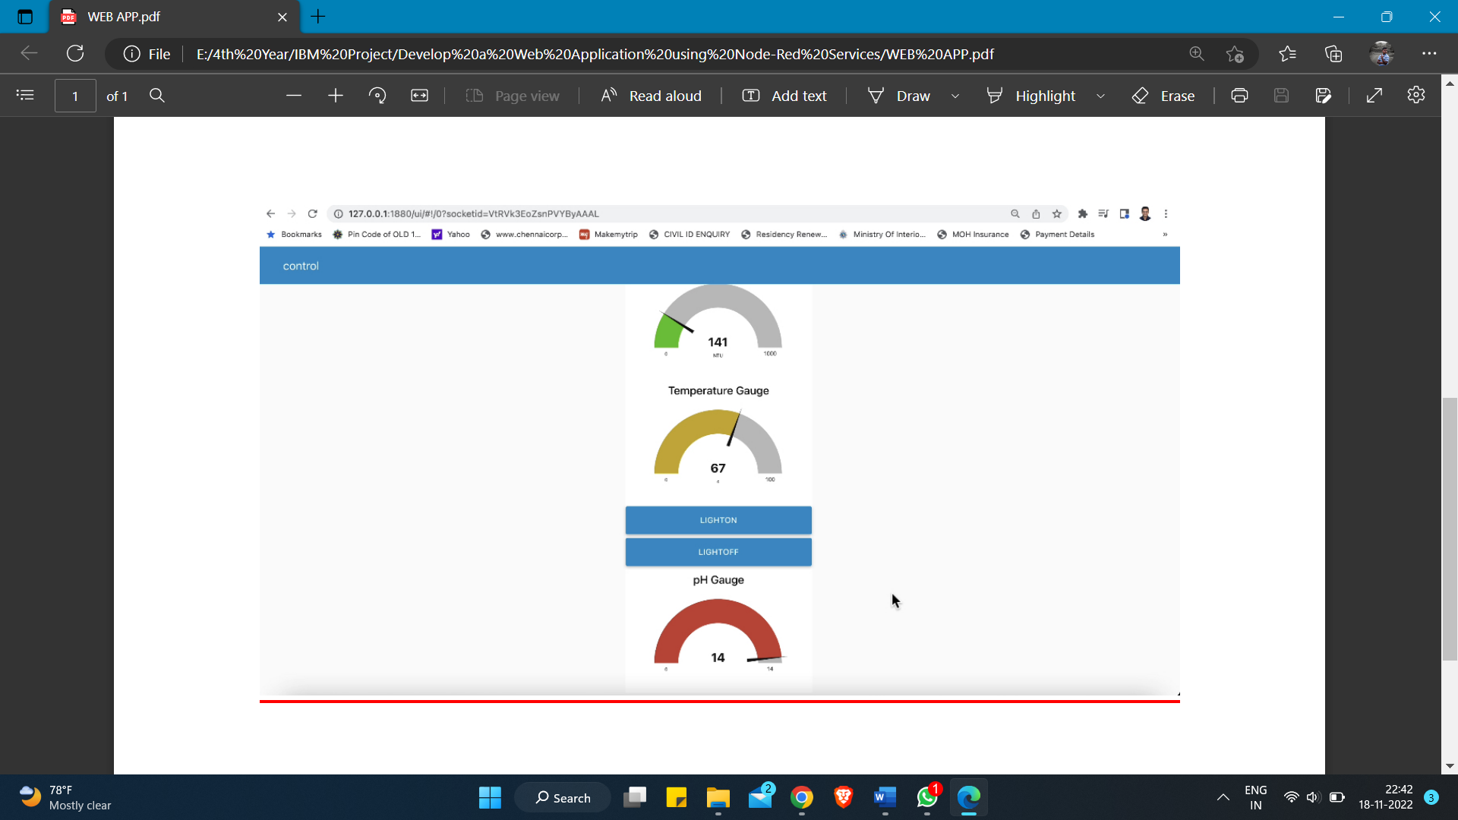

**8. TESTING**

* 1. **Test Case Analysis**

This report shows the number of test cases that have passed, failed, and untested

|  |  |  |  |  |
| --- | --- | --- | --- | --- |
| **Section** | **Total Cases** | **Not Tested** | **Fail** | **Pass** |
| Print Engine | 15 | 0 | 0 | 15 |
| Client Application | 45 | 0 | 0 | 45 |
| Security | 1 | 0 | 0 | 1 |
| Outsource Shipping | 2 | 0 | 0 | 2 |
| Exception Reporting | 10 | 0 | 0 | 10 |
| Final Report Output | 4 | 0 | 0 | 4 |
| Version Control | 3 | 0 | 0 | 3 |

# USER ACCEPTANCE TESTING:

1. **Purpose of Document**

The purpose of this document is to briefly explain the test coverage and open issues of the REAL TIME RIVER WATER QUALITY MONITORING AND CONTROL SYSTEMS

project at the time of the release to User Acceptance Testing (UAT).

1. **Defect Analysis**

This report shows the number of resolved or closed bugs at each severity level, and how they were resolved

|  |  |  |  |  |  |
| --- | --- | --- | --- | --- | --- |
| **Resolution** | **Severity 1** | **Severity 2** | **Severity 3** | **Severity 4** | **Subtotal** |
| By Design | 9 | 5 | 4 | 3 | 21 |
| Duplicate | 2 | 0 | 2 | 0 | 4 |
| External | 3 | 4 | 1 | 2 | 10 |
| Fixed | 10 | 1 | 5 | 17 | 33 |
| Not  Reproduced | 0 | 0 | 1 | 0 | 1 |
| Skipped | 0 | 0 | 1 | 2 | 3 |
| Won't Fix | 0 | 3 | 3 | 1 | 7 |
| Totals | 24 | 13 | 17 | 25 | 79 |

# 9. RESULT

* 1. **PERFROMANCE METRICS:**

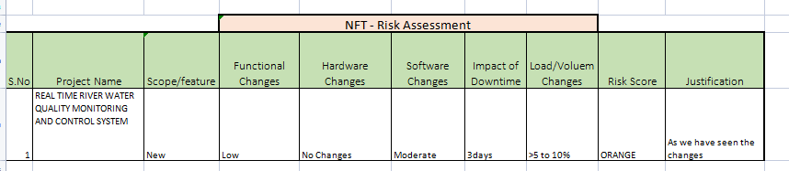

**PERFORMANCE TABLE**

|  |  |  |
| --- | --- | --- |
| PARAMETER | PERFORMANCE | DESCRIPTION |
| ADMIN TESTING | 95%-100% | THE TESTING DONE  BEFORE IT IS DEPLOYED AS AN APP |
| CUSTOMER SATISFACTION | 75-85% | THE CUSTOMER NEED TO BE SATISFIED WITH THE MOBILE  APPLICATION |
| USER INTERFACE | 65-85% | THE APP CAN USED BY ANYONE.(EASE OF  ACCESS) |
| SEVER RESPONSE | 50-75% | url - response |
| DATA VALIDATION  WITH NO. OF TEST CASE | 60-80%  (15-30  TESTCASE) | VALID DATA FROM THE APP |
| ERROR | 3-5% | REAL-TIME DELAY  MAY OCCUR |

**10. ADVANTAGES AND DISADVANTAGES**

**ADVANTAGES:**

* + - The prototype developed for water quality maintenance is very beneficial for safeguarding public health and also adds to the clean environment.
    - The automation of this water monitoring, cleaning and control process removes the need of manual labor and thus saves time and money.
    - The automation of the system makes the control and monitoring process more efficient and effective. Real time monitoring on mobile phone which is possible through the interface of plc with Arduino and Bluetooth module allows remote controlling of the system.

**DISADVANTAGES:**

* + - It is difficult to collect the water samples from all the area of the water body.
    - The cost of analysis is very high.
    - The lab testing and analysis takes some time and hence the lab results do not reflect real time water quality measurement due to delay in measurement.
    - The process is time consuming due to slow process of manual data collection from different locations of the water body.
    - The method is prone to human errors of various forms.

**11. CONCLUSION**

Thus, our project is used to Monitoring of Turbidity, PH & Temperature of Water makes use of water detection sensor with unique advantage and existing GSM network. The system can monitor water quality automatically, and it is low in cost and does not require people on duty. So, the water quality testing is likely to be more economical, convenient and fast. The system has good flexibility. Only by replacing the corresponding sensors and changing the relevant software programs, this system can be used to monitor other water quality parameters.

The operation is simple. The system can be expanded to monitor hydrologic, air pollution, industrial and agricultural production and so on. It has widespread application and extension value. By keeping the embedded devices in the environment for monitoring enables self-protection (i.e., smart environment) to the environment. To implement this need to deploy the sensor devices in the environment for collecting the data and analysis. By deploying sensor devices in the environment, we can bring the environment into real life i.e., it can interact with other objects through the network.

Then the collected data and analysis results will be available to the end user through the Wi-Fi.

**12. FUTURE SCOPE**

We use water detection sensor has unique advantage. It consumes less time to monitor than a manual method for checking polluted levels, and notifies immediately to reduce affected rate of pollution in water. People who are living in rural areas near to the river will be very satisfied with our idea. It will be useful to monitor water pollution in specific area. So, this system prevents people from water pollution. It will be used for farming purpose to check quality water, temperature, and PH level. Our Impact of this project is also creating a social satisfaction for farmers too. The scalability of this project gives the addition of more different type of sensors. By interfacing the relay we can control the supply of water. We can also implement as a revenue model. This system could also be implemented in various industrial processes. The system can be modified according to the needs of the user and can be implemented along with lab view to monitor data on computers.

**13. APPENDIX**

* 1. **SOURCE CODE:**

**PYTHON CODE TO PUBLISH DATA**

import ibmiotf.application

import ibmiotf.device

import time

import random

import sys

from twilio.rest import Client

import keys

Client = Client(keys.account_sid, keys.auth_token)

organization = "bvyu7c"

deviceType = "micro"

deviceId = "abcd"

authMethod = "token"

authToken = "12345678"

pH = random.randint(1, 14)

turbidity = random.randint(1, 1000)

temperature = random.randint(0, 100)

def myCommandCallback(cmd):

print("Command Received: %s" % cmd.data['command'])

print(cmd)

try:

deviceOptions = {"org": organization, "type": deviceType, "id": deviceId, "auth-method":

authMethod,

"auth-token": authToken}

deviceCli = ibmiotf.device.Client(deviceOptions)

except Exception as e:

print("caught exception connecting device: %s" % str(e))

sys.exit()

deviceCli.connect()

while True:

pH = random.randint(1, 14)

turbidity = random.randint(1, 1000)

temperature = random.randint(0, 100)

data = {'pH': pH, 'turbid': turbidity, 'temp': temperature}

def SMS():

message = Client.messages.create(

body="ALERT!! THE WATER QUALITY IS DEGRADED",

from_=keys.twilio_number,

to = keys.target_number)

print(message.body)

if temperature>70 or pH<6 or turbidity>400:

SMS()

def myOnPublishCallback():

print("Published pH= %s" % pH, "Turbidity:%s" % turbidity, "Temperature:%s" % temperature)

success = deviceCli.publishEvent("demo", "json", data, qos=0, on_publish=myOnPublishCallback)

if not success:

print("Not Connected to ibmiot")

time.sleep(5)

deviceCli.commandCallback = myCommandCallback

deviceCli.disconnect()

#Twilio Account Credentials

account_sid ='HCe9yeb9bf43aa629b503bdd01d0962d465'

auth_token ='58u3m0ade0472038ab36d45e0d9fb6e7'

twilio_number ='+197870199xxx'

target_number ='+919950555xxx'

**OUTPUT**

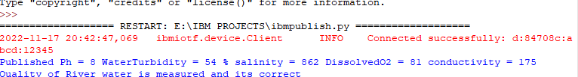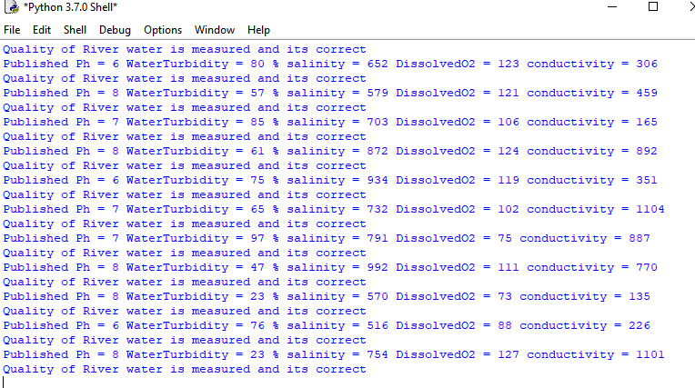

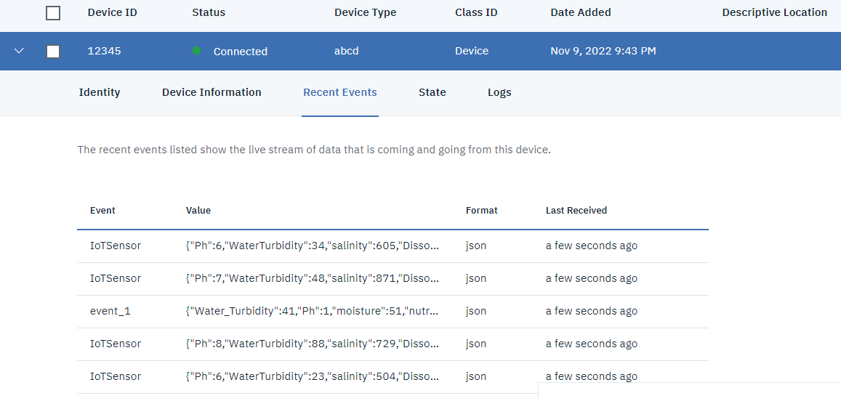



**HTML CODE:**

<!DOCTYPE html>

<html lang="en">

<head>

<style>

h1 {text-align: center;} p {text-align: center;} div {text-align: center;} body {

background-image: url("https://thumbs.dreamstime.com/b/clear-transparent-light-blue- water-pool-texture-background-150961732.jpg");

background-color: #cccccc;

}

</style>

<meta charset="UTF-8">

<meta http-equiv="X-UA-Compatible" content="IE=edge">

<meta name="viewport" content="width=device-width, initial-scale=1.0">

<title>Login page in HTML</title>

</head>

<body>

<h1>Login Page</h1>

<form action="">

<!-- Headings for the form -->

<div class="headingsContainer">

<h3>Sign in</h3>

<p>Sign in with your username and password</p>

</div>

<!-- Main container for all inputs -->

<div class="mainContainer">

<!-- Username -->

<label for="username">Your username</label>

<input type="text" placeholder="Enter Username" name="username" required>

<br><br>

<!-- Password -->

<label for="pswrd">Your password</label>

<input type="password" placeholder="Enter Password" name="pswrd" required>

<!-- sub container for the checkbox and forgot password link -->

<div class="subcontainer">

<label>

<input type="checkbox" checked="checked" name="remember"> Remember me

</label>

<p class="forgotpsd"> <a href="#">Forgot Password?</a></p>

</div>

<button type="submit" onclick="window.location.href = 'https://node-red-qltdp-2022-

11-07.eu-gb.mybluemix.net/ui';">Login</button>

<!-- Sign up link -->

<p class="register">Not a member? <a href="#">Register here!</a></p>

</div>

</p>

</form>

</body>

</html>

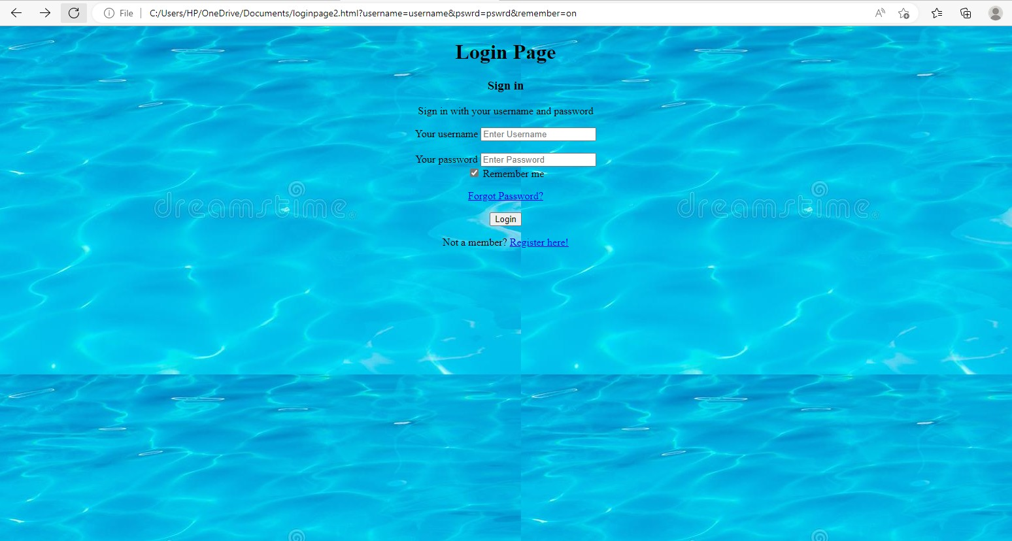

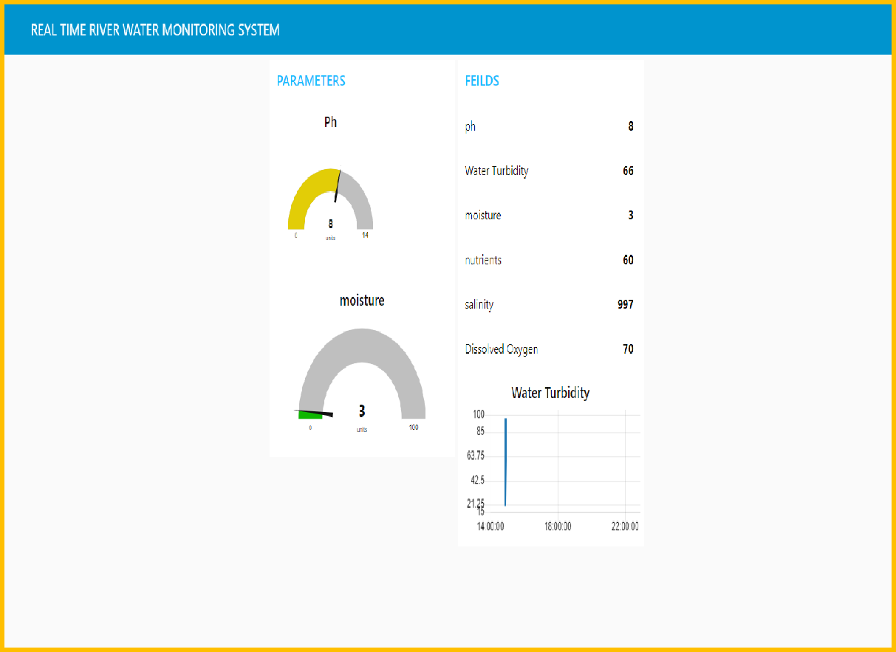

**MOBILE APP**

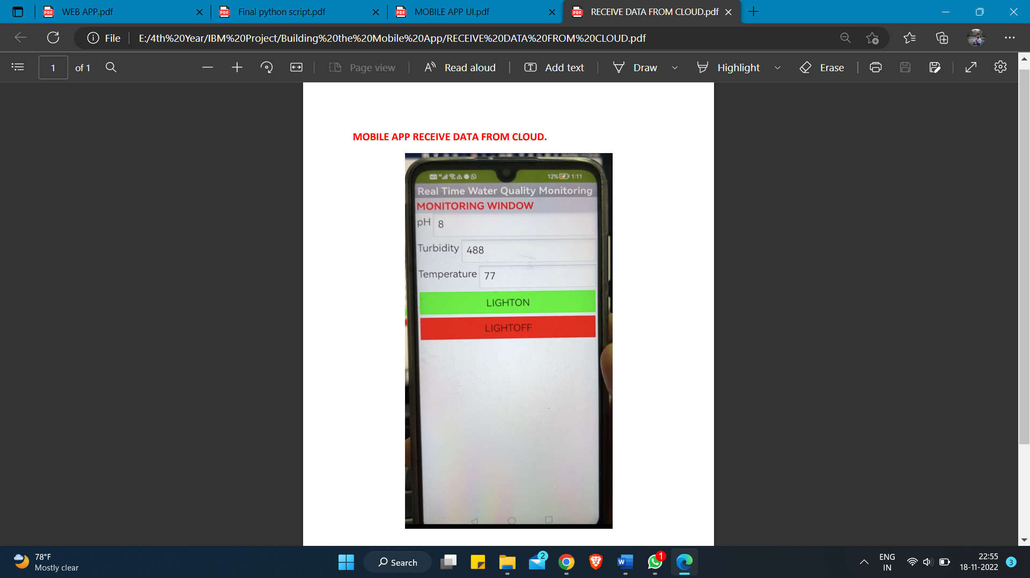

* 1. **GIT-HUB LINK:**

[**https://github.com/IBM-EPBL/IBM-Project-6995-1658844833**](https://github.com/IBM-EPBL/IBM-Project-6995-1658844833)

**PROJECT DEMO LINK:**

[**https://drive.google.com/file/d/1mjeY8b-zZrLCn9N9EWiTAd8-93A0j1cr/view?usp=share_link**](https://drive.google.com/file/d/1mjeY8b-zZrLCn9N9EWiTAd8-93A0j1cr/view?usp=share_link)